# Asynchronous code, LIBUV , Event loop , Streams , buffers, files and more…

## Javascript is Synchronous

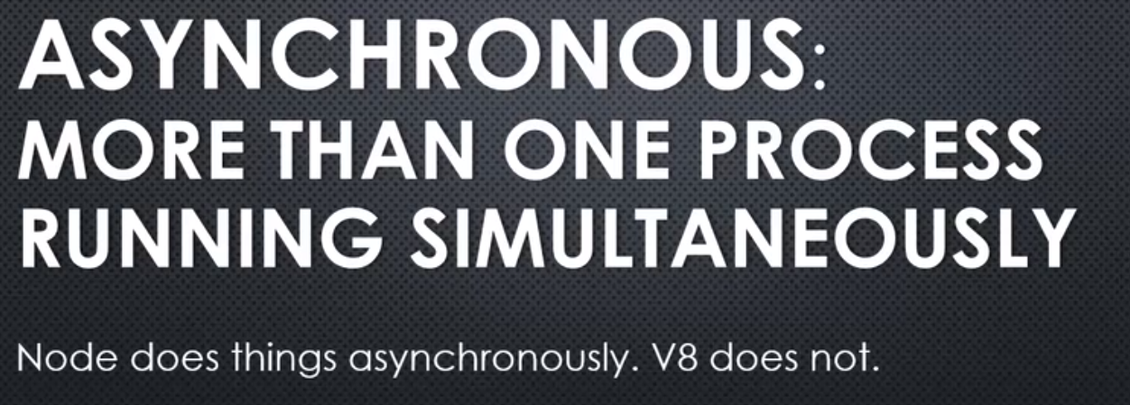

**We've seen in the C++ core, V8 engine is running, and there is a variety of things happening within Node itself. It's doing more than one thing at a time.**

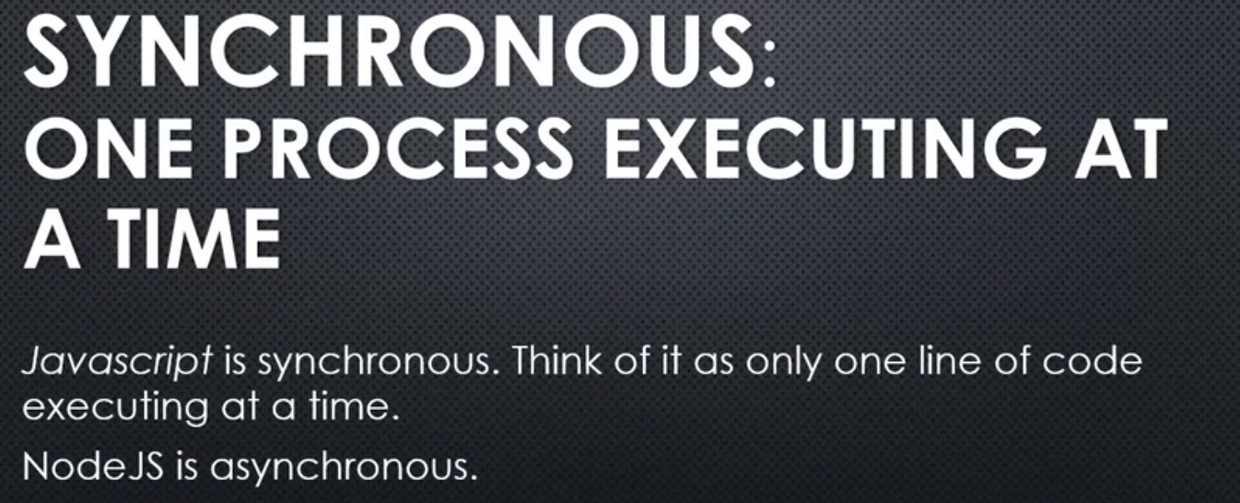

This is a common misconception when it comes to Javascript Node.

You may hear the term asynchronous Javascript, but that's really a misleading term.

**Javascript is designed to be synchronous. There's only one thing running at any point in time. Basically, one line of code running at any point in time.**

**But Node.js is asynchronous. V8 is inside of it, embedded. And so, while V8 is running Javascript code, converting it to machine language, executing it; Node can do other things as well. Not just let things run inside the V8 engine.**

**So, whenever we talk about asynchronous Javascript, we're not really talking about the Javascript engine itself, but rather, whatever the Javascript engine is sitting inside of; like the browser, or Node.**

**And, things happening inside the engine running simultaneously alongside the engine as well, and how the engine responds to things that happen outside of it. Things that are happening at the same time.**

## **VeryImportant - LIBUV , the event loop and non-blocking asynchronous code**

Alright, it's time to talk about the **other side of events in Node, libuv, the event loop, and non-blocking asynchronous code.**

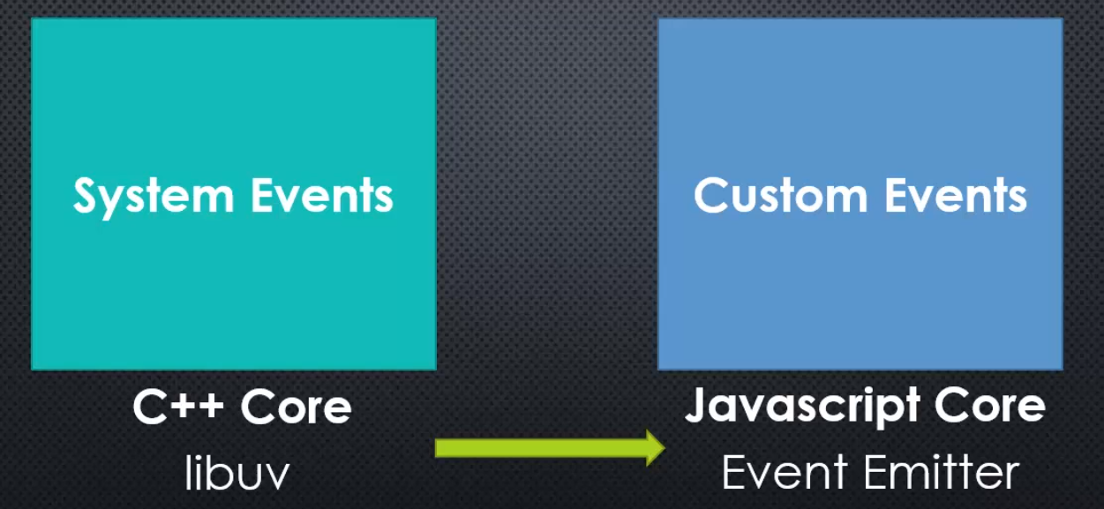

We've already seen the event emitter, the custom events that are JavaScript-based that exist inside Node. We said that that was really just a trick. It's really just an object with properties, and those properties are arrays of functions.

The other side of events is where it gets really deep and interesting.

**System events, handled inside the C++ side of the core, are actually handled by a C library called libuv, that's also embedded inside Node and is used elsewhere.**

**The idea here is managing events coming from the operating system closer to the machine.**

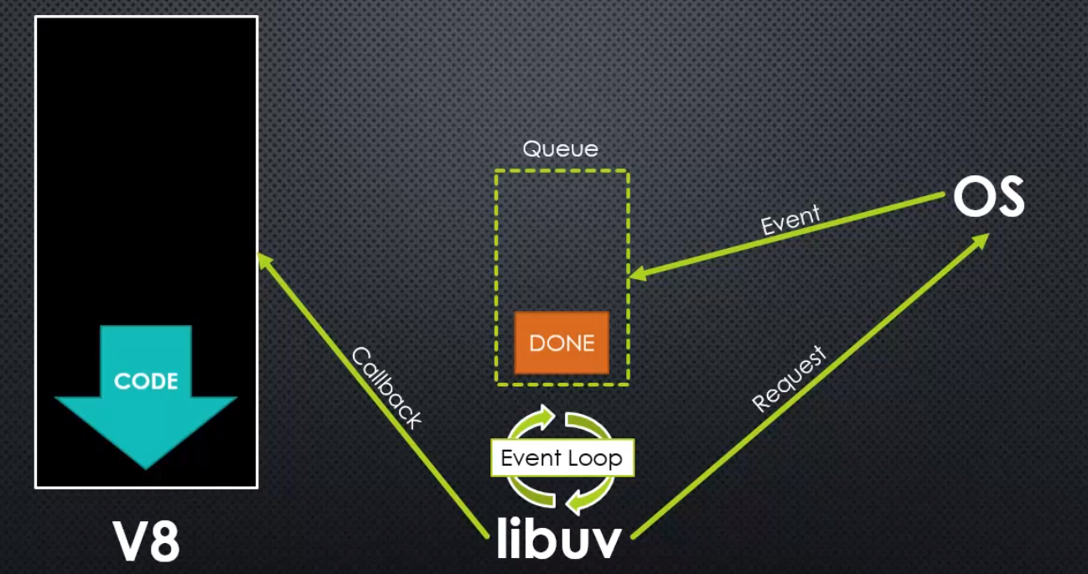

Inside Node, we have V8. JavaScript is synchronous, so V8 runs one set of code at a time, essentially one line of code at a time, and finishes that execution, and that keeps happening as functions are called, etcetera.

**Now, also inside Node, is libuv, another library. This one written specifically to deal With things happening lower level, events occurring in the operating system.**

**Libuv connects by requesting something from the operating system. Let's say it requests to download something from the internet or to open a file, and libuv inside of it has this queue, a queue of events that have completed.**

**This may be happening simultaneously while V8 is running its code.**

**Inside libuv, the most important part is called the event loop, and that's a loop in which libuv is constantly checking the queue that something has happened. This, again, is happening while V8 is running.**

**Then, at some point, the operating system, and this may take a while, depending on what you've asked of your computer to do, to download a large amount of data, to open a file, whatever the case is, or perhaps the internet connection is slow. Whatever happens, it's an event, and that event will get placed in the queue from the operating system. There may be more than one between checks, as the loop is looping.**

**On every loop, libuv checks the queue, and the operating system may put more than one, "Hey, I finished that" inside there.**

**When, while checking in that loop, libuv sees that something is complete, it processes it, and it runs a callback**, that is to say code that is meant to be run when that event completes, it's some code that we've said, "Hey, libuv, "this is code that should run when this other code "is finished running," and so we call it a callback. It's very similar to the idea of an event listener.

**That callback ultimately will involve, and usually internally, JavaScript code running as a response, but only when it's finished running any other code that it's running because** **JavaScript is synchronous, so it can only handle one thing at a time. JavaScript code may be running currently, and an event comes from the OS, libuv, checking the event loop, sees that it's complete and tells V8 to run some code, but V8 will wait to run that code until it's finished running the code that it's currently running because it's synchronous.**

**This entire process is asynchronous, because there are things happening in libuv and V8 at the same time, and all of this inside Node itself.**

### **Event Driven Non-Blocking I/O**



When we talk about Node, sometimes you'll see a tagline that looks something like Event Driven Non-Blocking I/O in V8 JavaScript.

We understand that V8 is embedded inside of Node, and that's what's executing the JavaScript code.

**when we talk about I/O, or input/ouput, that these are things happening at the operating system level, opening files, connecting to databases, and retrieving and sending information over the internet. These things happen at a core level within your computer system, and within a server.**

**so the event driven part is where we're asking for these things to happen and then we're getting an event notification when it's done, so we get this event in the queue, the event has happened, and the loop is constantly checking for that, and because your code, your JavaScript code, can continue to run, this is called non-blocking.**

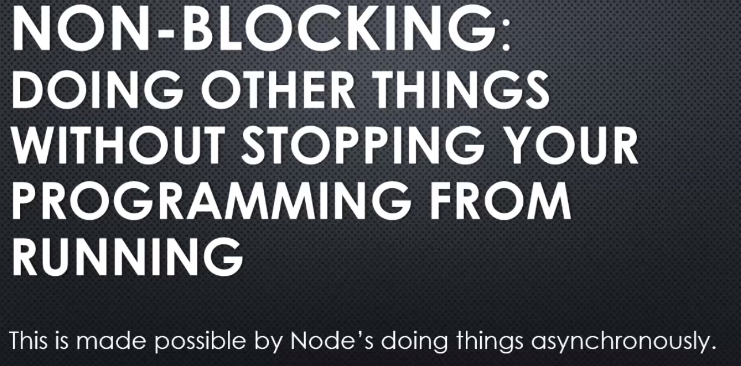

**blocking process means that, for example, let's say I said, "Go grab me this file please "and get the contents," and then I waited for the entire file to be read and all the contents to be pulled into memory, and then I moved on to the next line of code. The problem with that is as you get many users, and perhaps there is a variety of times that it takes for these things to occur, maybe the server slows down for some reason, maybe the file's extremely large, then you would end up blocking the next thing that you can do in your programme. Your programme would essentially seem to freeze while it's carrying out these other tasks.**

**With the non-blocking approach with Node, we ask Node to go off and do something else, and our JavaScript continues running, our programme continues running, and then, when the next time it is available, when the V8 engine is no longer busy, if an event has occurred, then libuv, within the node architecture, is used to run more code in V8 functions that we want to run internal to Node, and then the event emitter also lets us run our own code, because usually those events coming from libuv are also related through the event emitter, the JavaScript side, they cause a JavaScript event, so that we also can add our own functions that we want to run when something has happened.**

**so Node lets us write synchronous code in JavaScript that's very easy to manage, and still respond to things that are happening asynchronously.**

**we simply say, "Please run this code "when this thing over here is done, "and meanwhile, we'll keep running "this other code over here."**

### **Why NodeJS is high performant?**

**so that's the idea of the event loop and non-blocking event driven architecture that is at the core of Node.js, and what helps Node.js be very performant, high performance, because many people can ask for the server to do many things, and we won't block; we'll keep running JavaScript, and people can keep coming in and requesting things to happen, and as things finish, we respond.**

### **Libuv**

Libuv actually has its own website.

**it's a module that was built primarily for Node, but can be used elsewhere.**

**Libuv** - **asynchronous I/O made simple. In other words, as we said, helping us to manage more easily when multiple things are happening simultaneously.**

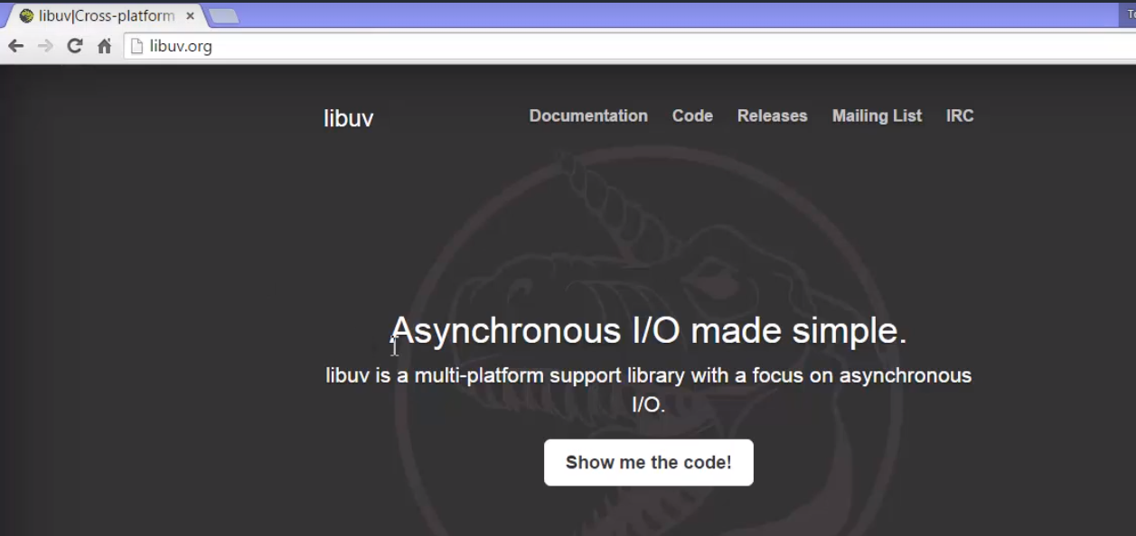

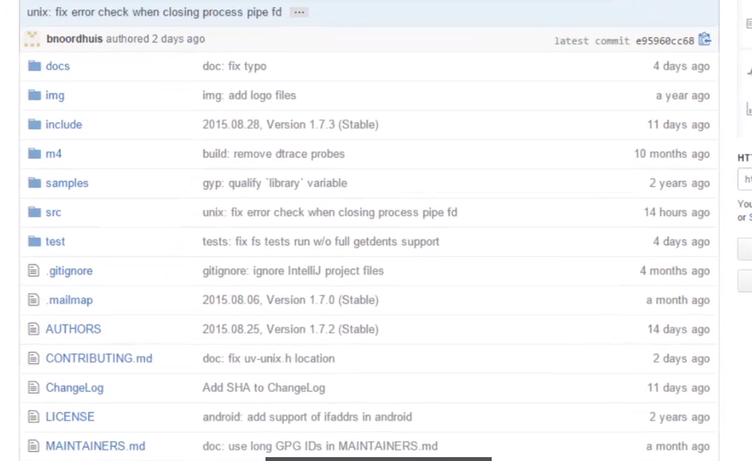

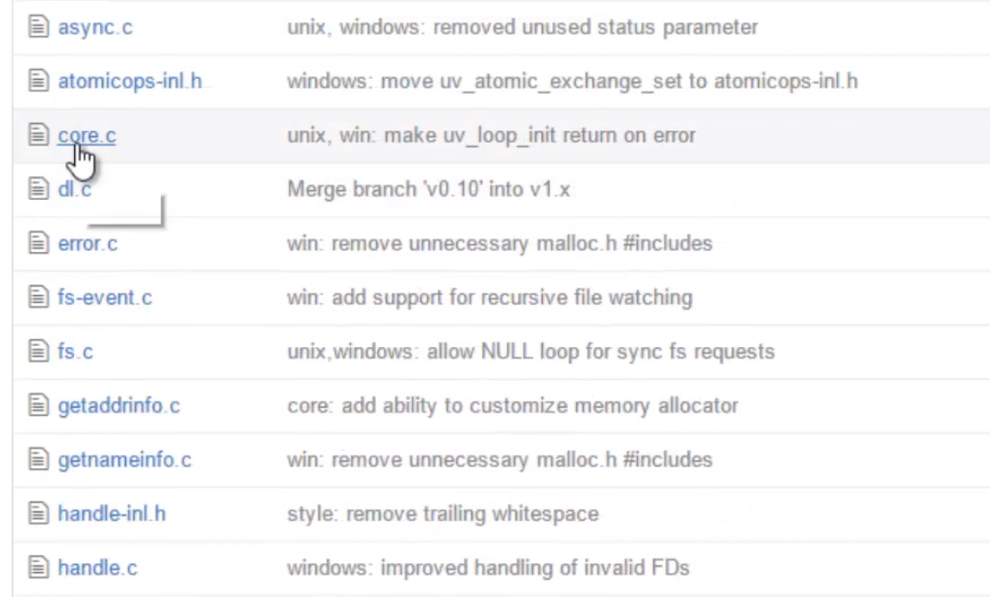

It's C code, and as we can see, the tag here, on the current website as of the time of this recording, it says, asynchronous I/O made simple. In other words, as we said, helping us to manage more easily when multiple things are happening simultaneously.

You can go into the documentation and read more about the design patterns and concepts within libuv. I'll just click on Show me the code! and it will take me over to the GitHub repo, github.com/libuv/libuv.

Just to show you an example,

if I go into the src folder, the source code, I'll see that it's a bunch of .c and .h files, so I'm dealing with C code. I'll just go into the win folder, just to show as an example, and go to the core.c file.

**If I do a search for uv_run, this is libuv's primary loop about to run; in fact, when we said the event loop, that's exactly what we meant.**

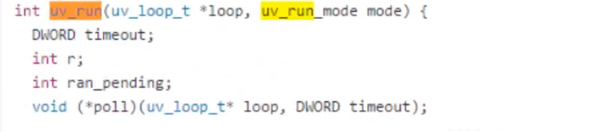

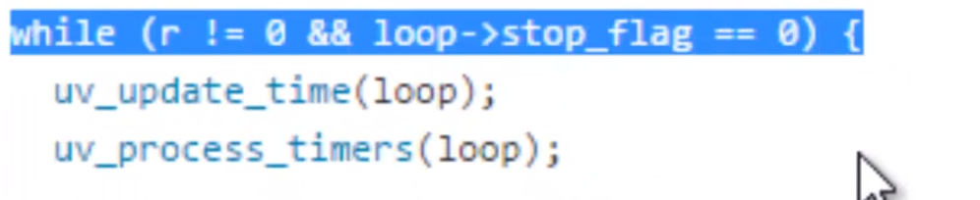

**That's a while loop. That is the event loop.**

**This while loop keeps running inside this C code, checking for things to invoke, checking for events to have been completed and callbacks to run, and so this is constantly running in the background. As long as there are events that it needs to listen for, it will run and wait**

**while our V8 code is running, while our JavaScript is being processed through V8.**

## Streams and Buffers

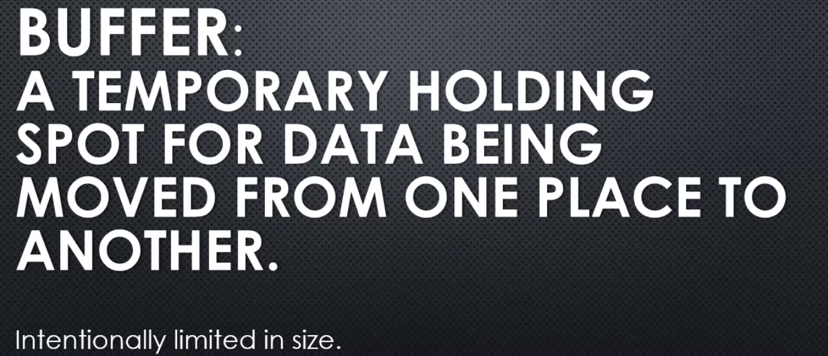

We store it there and it's temporary. We'll move data into a buffer then move it out and move new data into a buffer. But **it's really just a spot in memory**.

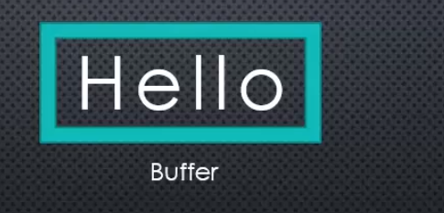

And generally, this data is coming and moving through, usually, what's called a stream.

a sequence of pieces of data, data that's broken up into what's called chunks.

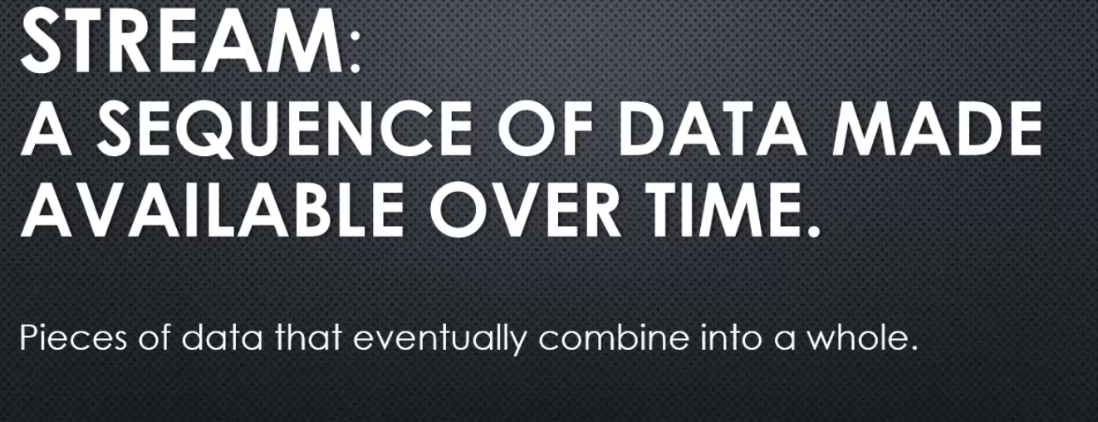

for example, a stream over the internet might move at different speeds depending on how fast your internet connexion is.

But it's data being moved, being passed from one computer to another or from one process to another within the computer. And, we have this data moving, this sequence, this stream, and we're usually processing it as we go. Instead of, perhaps, trying to wait for all the data.

For example, when you stream a movie over the internet. The movie streams you don't download the entire movie. If you download the movie, that takes a long time. But if you stream the movie, you are downloading the whole movie, but you're downloading it as it comes. And you're watching it as it comes.

So you're processing the data as the sequence of data is moving. You're watching the video, as the video is being downloaded.

So that's the idea of a stream.

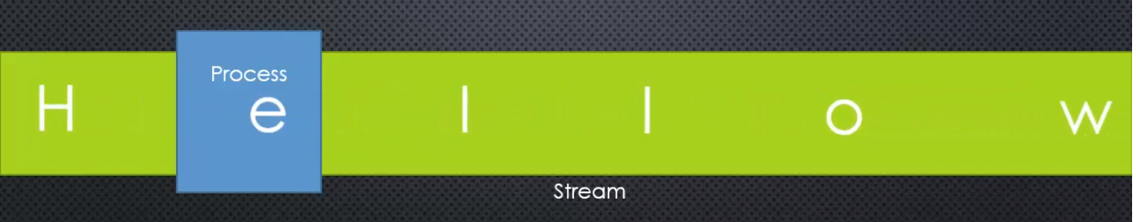

**The stream is data moving, and usually we're processing it in some way. We're gathering it, we're reading it, we're making decisions based on it, or we're storing it.**



**And a lot of times, we actually are combining the idea of a stream and a buffer.**

**Data comes down the stream, a certain amount of data is gathered into the buffer, and then that is processed. And then, it happens again, as we continue to get data until the stream is done, until the data that's trying to be streamed is complete.**

## Binary Data , Character Sets and Encoding

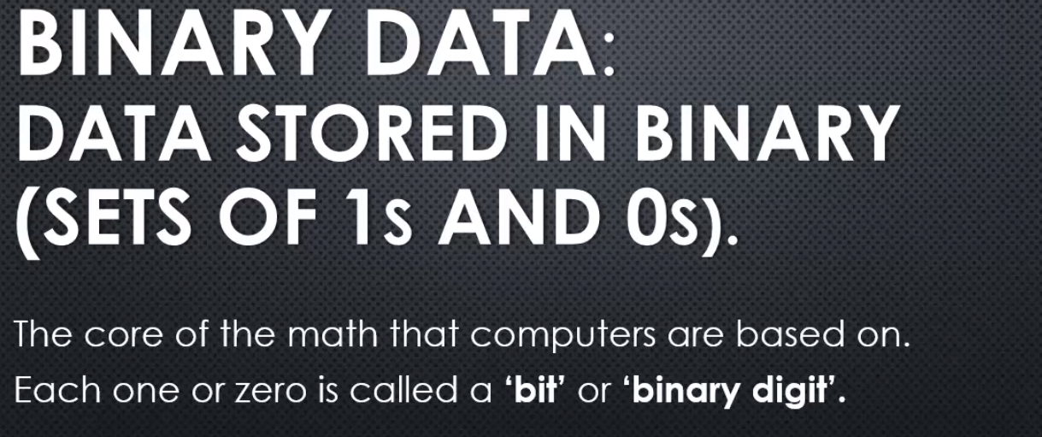

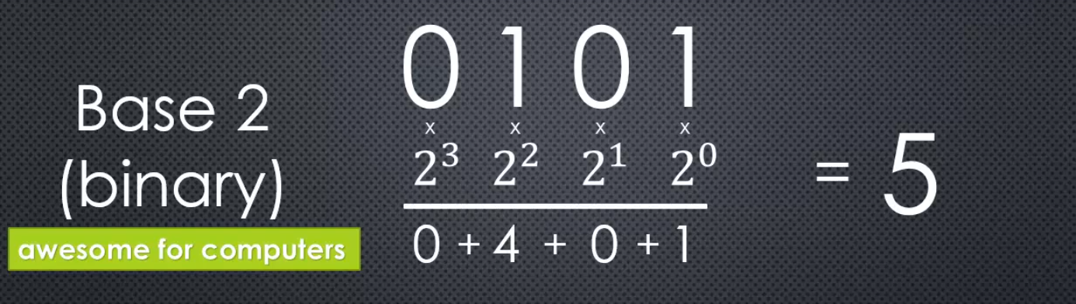

This is the number five in binary.

**And because each place we're calculating based on two to the something power, we call it base two. That's binary.** It's base two representation of a number, and we only need then two digits to represent this number.

It actually works the same when you're dealing with numbers that we're used to. Like, 53.

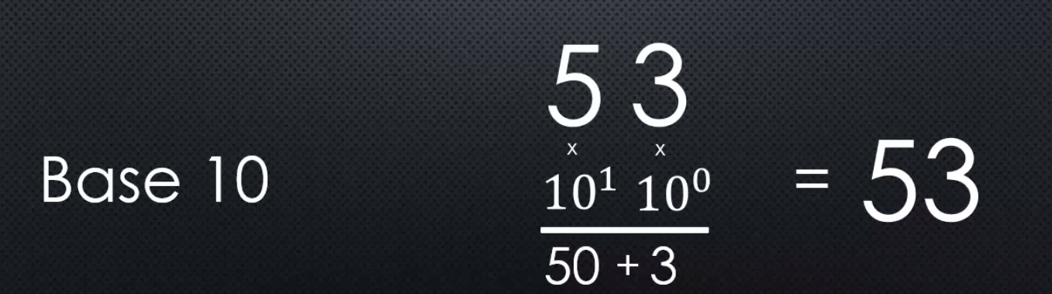

But binary only needs two digits to represent numbers. A zero and a one. And for that reason binary is awesome for computers. Because we can easily represent binary data physically.

For example, inside a blu ray or a DVD,

we're representing binary data with bumps. As you move the CD or Blu Ray as it's spinning,lasers are hitting the Blu Ray and bouncing back, and as they transition from a bump which is slightly elevated, to not having a bump which is lower and vice versa, it registers that as zeroes and ones. So depending on where the bumps are placed on either side of the bump can represent a one, and then when not in a bump, can represent a zero. So, you have a way physically to represent zeroes and ones.

Inside your computer there are transistors. Essentially, whether electricity is flowing or not. Switches, like the light switch in your house. Imagine every light switch being,

on being one, and off being zero. I can represent a number with switches, and there are a lot of switches inside your computer. And the same is true with your hard drive,

and with flash drives and everything else. They're just different ways of physically representing an on or off state. A zero or a one. And because of that we can physically store numbers, and that let's us store data.

And that actually takes us to the idea of character sets, and character encodings.

Because everything we store is in binary. Which means everything we store is really numeric. We're storing numbers. And that means **in order to store other kinds of data, we have to represent everything we store as a number.**

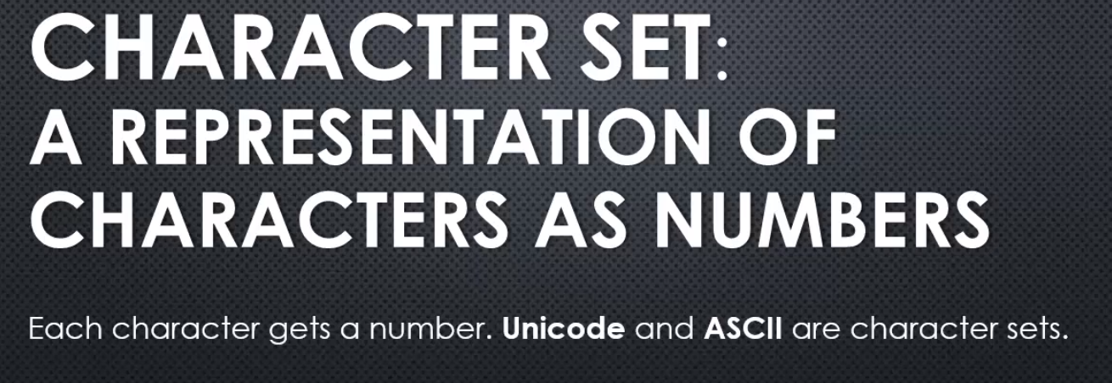

Unicode, ASCII, those are types of character sets, where characters get a number assigned to them.

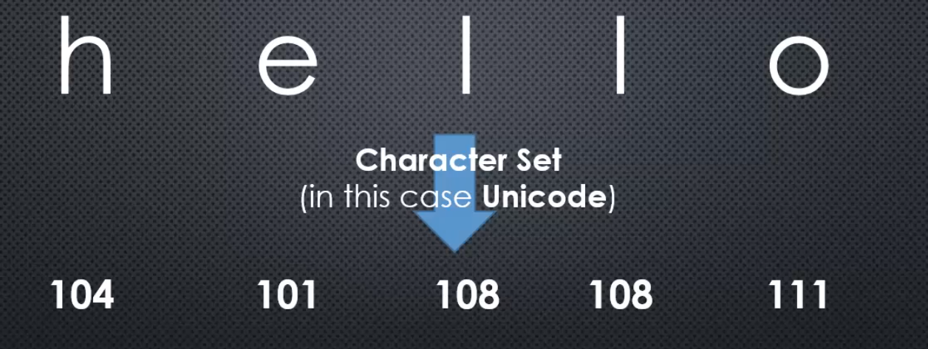

I can give each letter in the alphabet, and every other character I might type, a number that represents it.

And, what number I decide to give it, what number each character gets, defines a particular character set.

In this case we're showing you what each letter gets in the Unicode character set

but there are other character sets. And all it is, is me saying, "Hey, I'm going to decide

on a number that means a particular letter."

**So I can map a number to a letter, that's a character set.**

Now Unicode is very popular,because while we may have a small amount of characters and languages like English, and Spanish, and French, and others, there are other languages that require a lot more characters like Japanese, or Chinese, or others.

And so, we need larger character sets, and for that reason we need bigger numbers, because we need more numbers available to us to be able to represent all the characters.

And that means we need more bits for every character. So in this case we're just saying that we're going from the letter to a number.

But **remember, the number itself is stored in binary.**

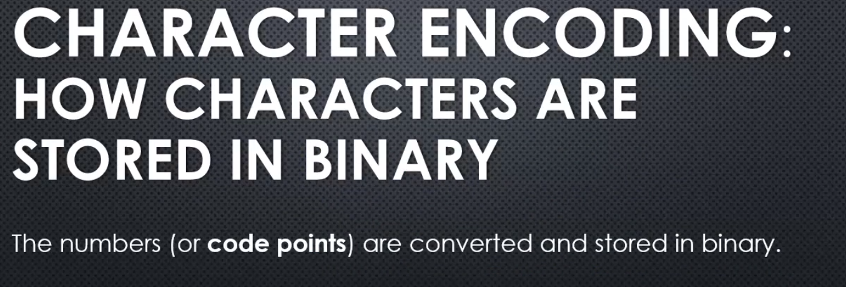

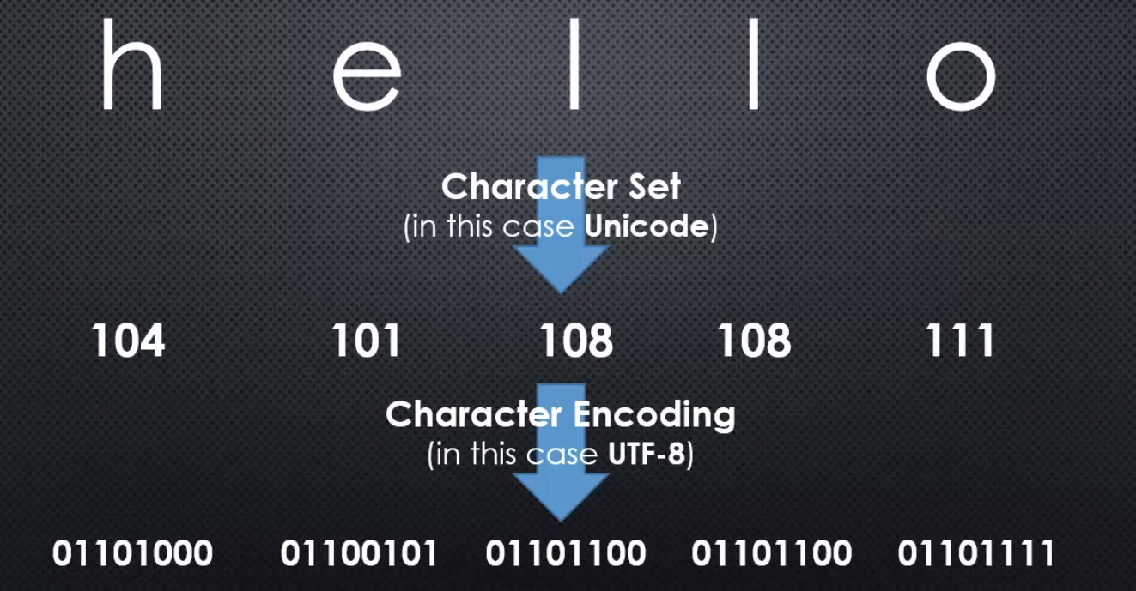

character encoding-How characters are stored in binary.

So those numbers from the character set, those are called code points.

And they're converted and stored in binary. Now, there are different ways that I could store a number in binary. And so, I have a number and the character set says, alright, here are the numbers that each one represents. And then, the character encoding, in this case we're showing UTF-8, determines how we're actually going to store the number in binary.

Now, you might be thinking, but there's only one way to store a number in binary.

Each number is specific zeroes and ones, and that's true.

But when we're talking about encoding, what we're really talking about fundamentally, is how many bits we use to represent each number.

**In this case, UTF-8, we have eight bits, eight digits to represent a number. You can see that each number gets eight bits available to it, even if it doesn't need all of them. Even if there zeroes to the far left.**

**And the reason is, because the more bits, the more digits we have, the bigger the number we can represent.**

So UTF-8 is popular, because the more numbers we have, the more characters we can use, and so it's great for international usage for languages that have more characters than others. And, all these zeroes and ones don't have the spaces like they do here, but rather are just crammed together as a sequence of data.

**character sets**- what number is each character represented by. We assign each character, letters, and symbols, a number.

**Character encoding** - means how many bits are we using to store that number. The more bits, the more characters we can store because the number is bigger.

when dealing with a server, you need to be able to deal with binary data, character sets, and character encodings.

And **historically, JavaScript is not very good at the encoding part. JavaScript handles Unicode okay, translating letters to numbers, and back and forth, but the pure raw binary data, JavaScript doesn't have a lot of features to deal with.**

**And so because of that, Node, with V8, the engine embedded in it, expands on the JavaScript language, and gives us some mechanisms to deal with binary data. Raw zeroes and ones.**

This is good because, if we're dealing with files or information flowing across the internet, in JavaScript we need to be able to deal with binary data.

## Buffer

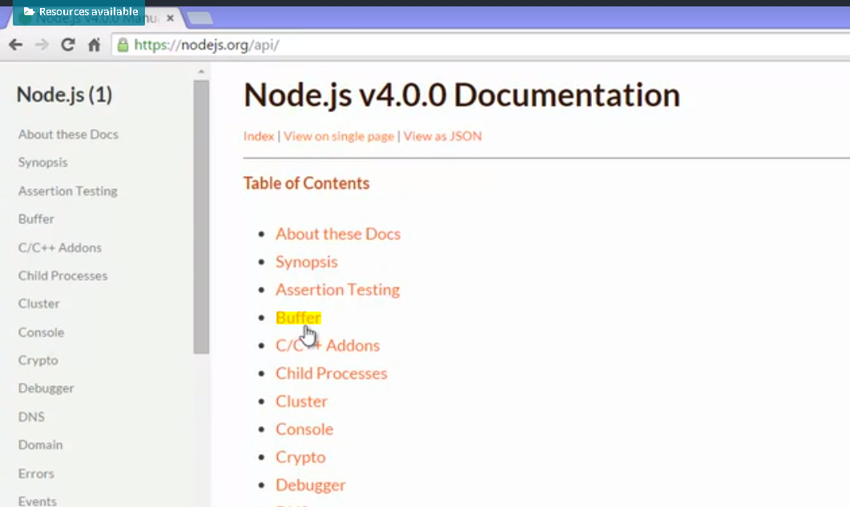

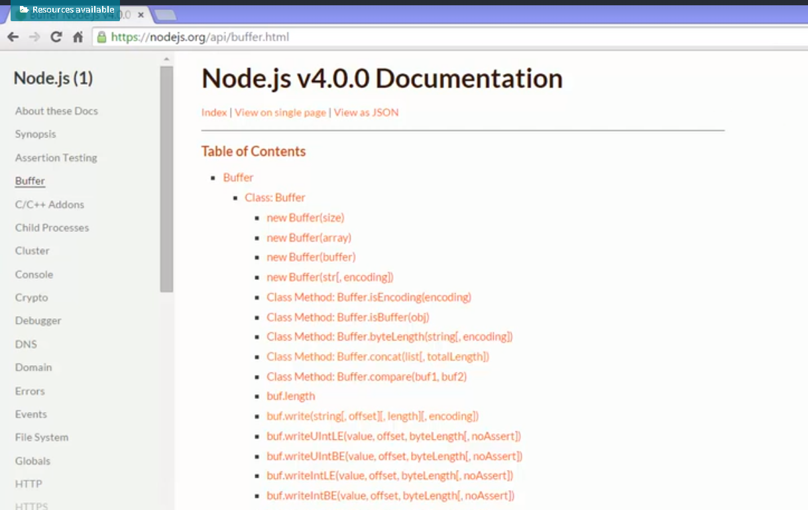

Go to Docs and then the API and we can look at the built in buffer object.

The buffer is created on the C++ side of the Node core and then made available to the JavaScript side.

And it stores binary data and it has a lot of methods for things that you can do to deal with binary data. We can convert between buffers and strings for example. So we can store strings as binary data in a buffer with a particular encoding.

But ultimately the buffer holds raw binary data. Zeroes and ones. But it does let us figure out how to switch between those zeroes and ones and strings assuming that we're storing string information.

I'll create a variable and make it a new buffer. Now, we're going to notice that because buffer is such a fundamental concept within Node,

Instead, nodejs made it global. globally available to JavaScript.

Kind of like JavaScript already has dates, for example, and can make a new date. Well you can just make a new buffer without having to use the require statement.

However, we do have to give it some data. So I can either make a buffer and say the size because the buffer is intended to be a particular finite size, particular amount of memory or I can just give it some string value and I can specify the encoding. Now if I don't specify the encoding, if I leave this off, utf8 is actually the default.

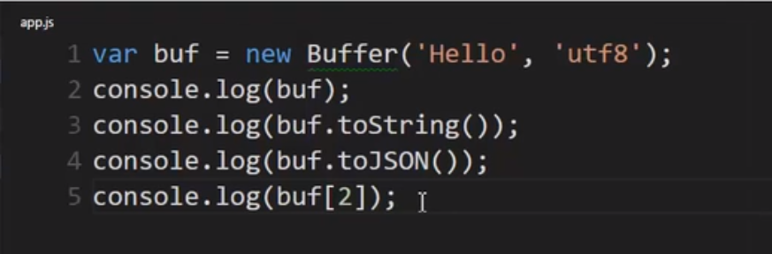

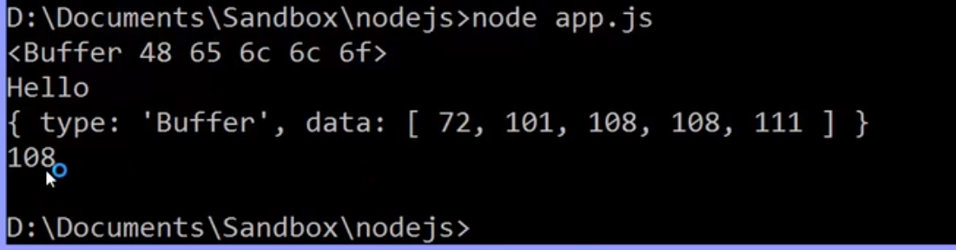

**The buffer itself behaves rather like an array. So I can actually go out and use brackets to get a particular one of those numbers.**

 I can also write data to the buffer

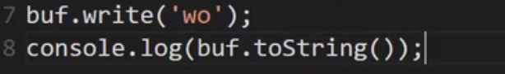

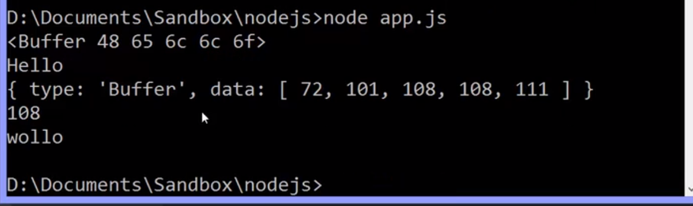

this time notice that the wo overwrote the he in hello. Remember that buffers are meant to be a finite piece of data. Just a certain amount of memory available that things will be coming into and leaving.

So when I wrote the buffer since I initialised it to allow for five characters, it overwrote those two. It didn't expand or stretch, it simply started overwriting the data in the buffer.

**Because the expectation is that as things come into the buffer, we pull them out when the buffer is full and process it and keep putting things into the buffer.**

## ES6 Typed Arrays

We said that buffers exist in Node because JavaScript didn't have good ways to deal with binary data.

Well, that's changing a bit in the next version of JavaScript, in ES6, the latest version.

So let's take a moment to talk **about ES6, typed arrays.**

**the latest version of the V8 imbedded engine, has access to something that can deal with binary data.**

I'll say var buffer equals and then I'll create a new ArrayBuffer. Then, I'll say a size, it wants a size in bytes. A byte is eight bits.

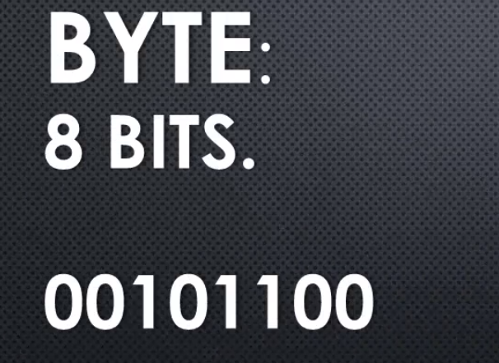

Remember, a bit is a binary digit, zeroes and ones. In other words, a byte is eight zeroes or ones. I'll say eight bytes. **So this is storing raw binary data.**

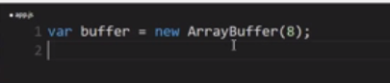

This is storing eight bytes, that is eight times eight, or 64 bits of data.

**This is not coming from Node, this is coming from the V8 JavaScript engine, this is a new feature in JavaScript. This has nothing to do with Node, it's just there because V8 is embedded in Node.**

How do I deal with my binary data?

Well, I can create what's called a **view**.

**The view is actually a typed array**, meaning that it's an array and I can deal with it as an array**. I'll create an Int32Array, and then give it the buffer to work with.**

What it really is, though, is it's simply a way for me to deal with the binary data in the buffer.

**If I changed the array, I'm actually changing the buffer. When I read from the array, I'm actually reading from the buffer.**

and it will convert that binary data into whatever structure I say is the structure that I should be looking at.

So in this case, **I said Int32. That means a number, an integer, stored with 32 bits, 32 zeroes and ones.**

So how many numbers can I store in my buffer?

Well, this is eight bytes. That is, a byte is eight bits, so this is eight times eight, 64 bits.

And this is 32 bits for one number. We'll use 32 zeroes and ones to store one number, which means we can store pretty big numbers,

but we can only store two numbers in this view as we have assigned 32 bits for one number.

So, I can use it as an array and I can use regular base 10 numbers. Then, I can console.log the view, and I can see the data in regular base 10, even though, see that?

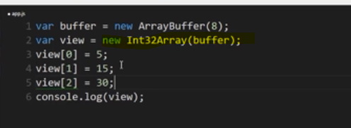

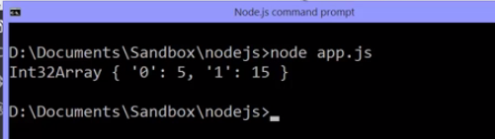

**the zero position holds a five, the one position holds a 15, even though what's really happening is this is being converted into 32 bits for a five, and 32 bits for a 15. Because the array buffer only holds two bytes, then, all I can do is store that.**

if I tried to put a third number in there, it doesn't error, but it's not there, the buffer doesn't have the storage for it.

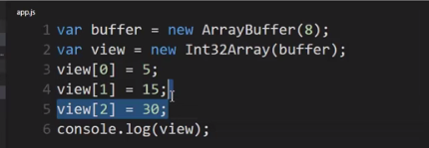

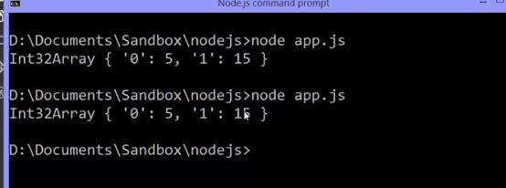

**So this view is just letting me work with binary data in an easier way. Letting me put in normal base 10 numbers.**

We're not going to use this through the rest of the course because right now **Node doesn't use this itself, it uses the buffer that's internal to Node and the C++ side.**

We should be aware of it because we don't want to walk away thinking, oh the buffer is there because JavaScript can't deal with binary data. It used to not be able to deal with binary data, this is new for ES6. It's availability depends, again, on what version of Node you're running.

However, it's good to know about so that we have clear in our minds that the **new version, ES6, the new version of JavaScript, does have ways of dealing with raw zeroes and ones, with raw binary data.**

## Callbacks

**a function passed to some other function which we assume will be invoked at some point. So the function that we're calling calls back invoking the function we give it.**

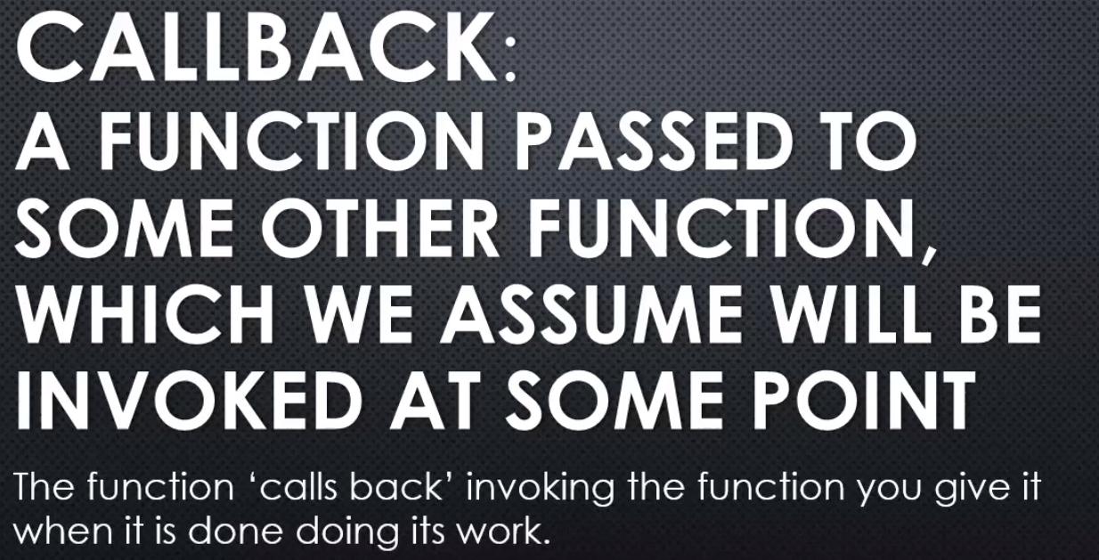

Callback is some code you give to other code to be run at some point while that other code is running.

let's take a quick look at how we do that in JavaScript.

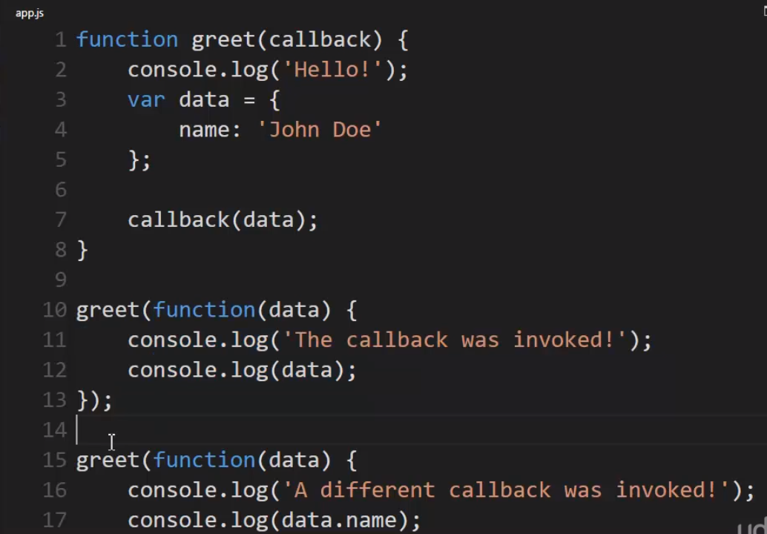

I could name this whatever I wanted. I'll name it callback to be clear. And the callback will be a function itself. Remember functions in JavaScript are first class so I can pass them around, set them to variables, et cetera.

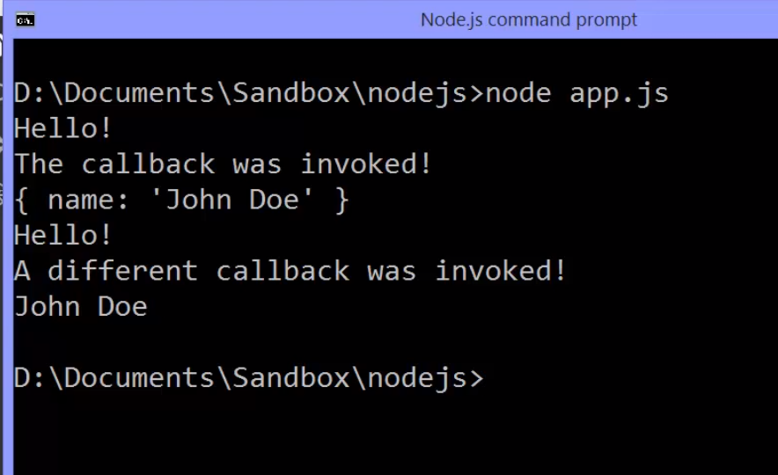

**So there's lots of things you can do with a callback pattern.**

**You could, for example, have a function that goes out and gets data from the database, but then you might call that function different ways at different times. And want to do different things with that data. So you could just give it a callback, have it give you the data and then do what you want to with the data.**

The function I invoke will invoke later the function that I give it.

## Files and fs

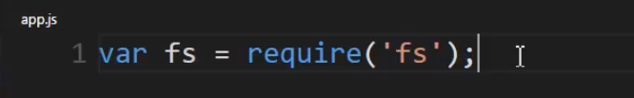

using require to get the built in fs module.

**That's fs.js inside the node source code on the JavaScript side of the core, and that deals with the file system that wraps up the C++ code that lets me get lower level and deal directly with files.**

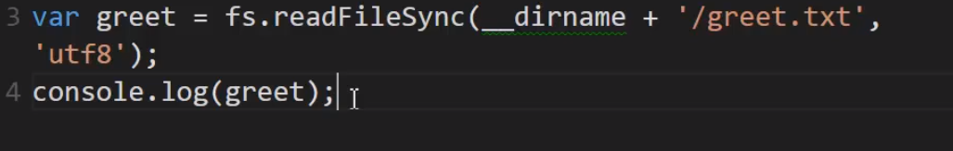

we'll use a method on the fs object because I get back an object from require;

**Now, we're dealing with files on our operating system; so that means we're dealing with, normally, binary data.**

**So I need to be able to deal with binary data in reading the file.**

So I'll call **fs.readFileSync.**

it takes some parameters. The first thing it takes is the location of and name of the file.

Now I've put it here at the same level as my app.js file. To be clear then, I'll use __dirname.

and it gives me the path to the directory that the code I'm running lives in.

**I can also specify the encoding as the second parameter here. That's not required because it will by default be utf8**

**it will read the binary data, and then it will use the encoding to determine what those zeros and ones mean, what they ultimately map to as characters.**

And **this wraps in the concept of buffers because if I go open up in the node.js source code, the readSync method inside fs.js;**

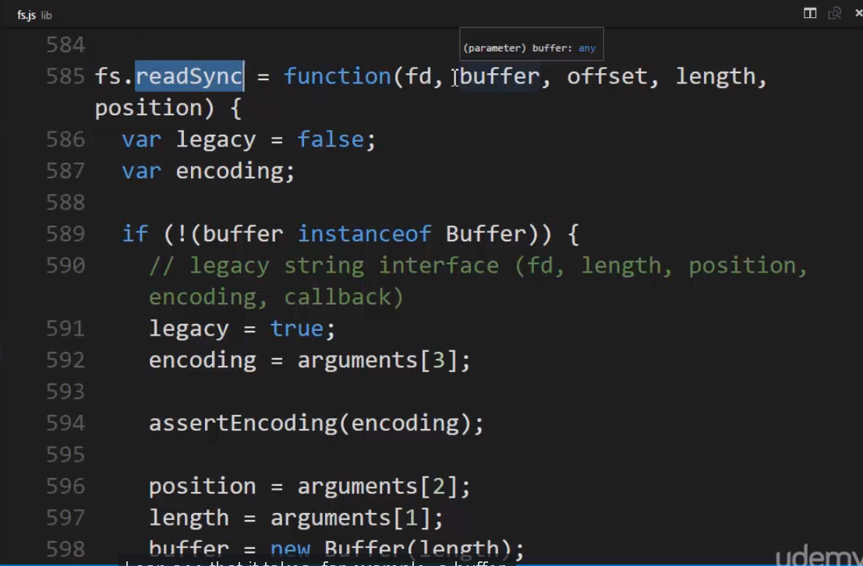

I can see that it takes, a buffer.

**When this is called, it's given a buffer. And so it loads the contents of the file into the buffer.It needs to because the buffer can deal with binary data.**

**So when my file is read, it loads the contents of the file into the buffer first and then uses the encoding so that I can get the string back.**

**So after that happens, I can now use my variable, which now has the string. This file was read off of my hard drive. It used the proper encoding to get me back the proper characters from the binary data.**

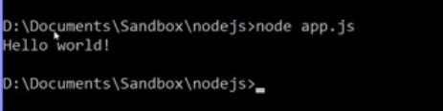

this is a **synchronous approach** to reading the file. That means that when this line of code is run by the JavaScript engine, it will wait until the buffer is filled and it has the string back before the V8 engine will move on to the next line of code.

**Now, this can be useful when, for example, you're setting up initially your application, the first lines of code. Maybe you have a configuration file of some kind and you need to read that before any other code can run. That's a perfectly valid reason to wait until the file is finished reading in order to move on to the next line of code.**

**But in most cases, you don't want this to be synchronous because perhaps you have many people requesting information from your node application; and if you have many simultaneous users, what's going to happen is they'll all end up blocked because JavaScript is synchronous even though node is asynchronous.**

When we say to read this synchronously, we're asking JavaScript to just run this in its normal synchronous manner, which means that others requesting the same code to be run simultaneously will end up waiting a long time because you might have many users and we're waiting for the file to be read. If the file is very large, we end up with a very large buffer. It could take a long time, relatively, in computer terms; and so your application could slow down the more people you have requesting this code to be run.

Because every time it's run, it stops and waits for a long process to finish, potentially, especially if the file is extremely large. The larger the file, the longer the process;

**asynchronous method of handling this by node.js – readFile()**

this takes a callback, and the callback function that I provide will take two parameters: an error and data. If we were to go look at this in the node.js source code, also in fs.js, we see the readfile method, which takes a callback.

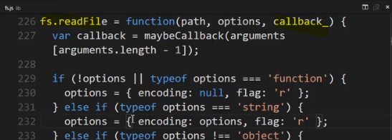

**ultimately, what happens is it goes off and says, all right, C++ code, do your thing.**

**Libuv will go and ask the OS to do the work, and then when the event is complete, when it has finished reading the file, please run this JavaScript code.**

**it might take a long time for this file to be read; and that's okay because the JavaScript code will simply keep running and then the event loop will keep checking and when the file is finished reading and I have my string, it will say you can now run this callback.**

**And as soon as the JavaScript engine is finished running whatever other code it's running, it will invoke this function; and when it invokes this function, if there was an error, it will pass it as the first parameter, and otherwise, any other data. And if there's no error, it will be null.**

By the way, this is popular pattern in node called error-first callbacks. 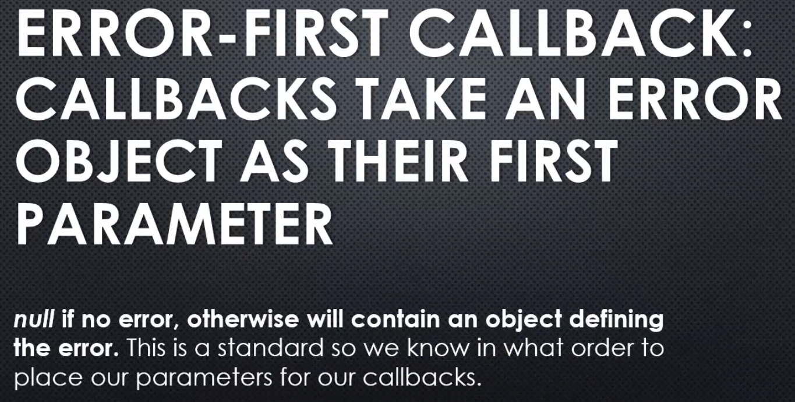

**The JavaScript will be running through V8 while simultaneously I'm asking node to go and read the contents of this file. And thanks to the event loop, I will simply have this function invoked when that work is complete and V8 has nothing else that it's doing.**

**That's the power of asynchronous code and callbacks. Because if I had many people requesting this app and asking it to do things and working with it, this call to reading that file, especially if it was large, wouldn't slow down the application for people. They would simply be able to keep working. The app wouldn't freeze or hang because this is being done asynchronously and V8 is still running the JavaScript. So they could continue asking for other things, getting other data; and at some point, this callback will be invoked.**

**When you think about writing node code, you should always lean towards the asynchronous approach versus the synchronous approach whenever available because it will make your applications, your software, more performant. It will make it seem faster. It will be a better experience for your users. So wherever you can, if there's an asynchronous method available, use that one wherever you can.**

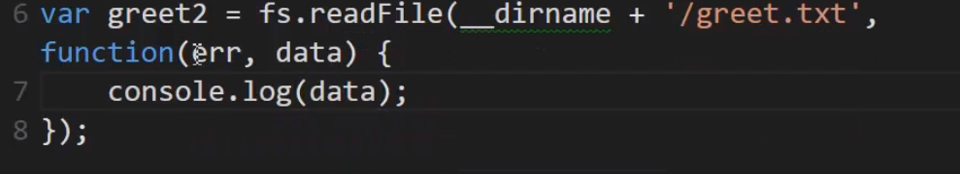

Output -



**so what comes back, by default, is a buffer. remember, it's loading binary data; so that's what it gave me, a buffer full of the binary data. A buffer full of the contents of that text file.**

**Now I could convert this using the buffer to string, or I could just say, as my second parameter, the encoding that I'm expecting this to be, this file. If I include that parameter, then it will convert the buffer to a string and give me back the string.**

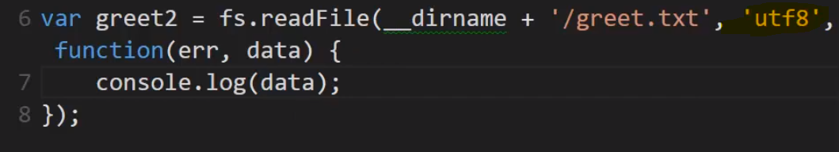

To prove asynchrounous call , here’s an example - 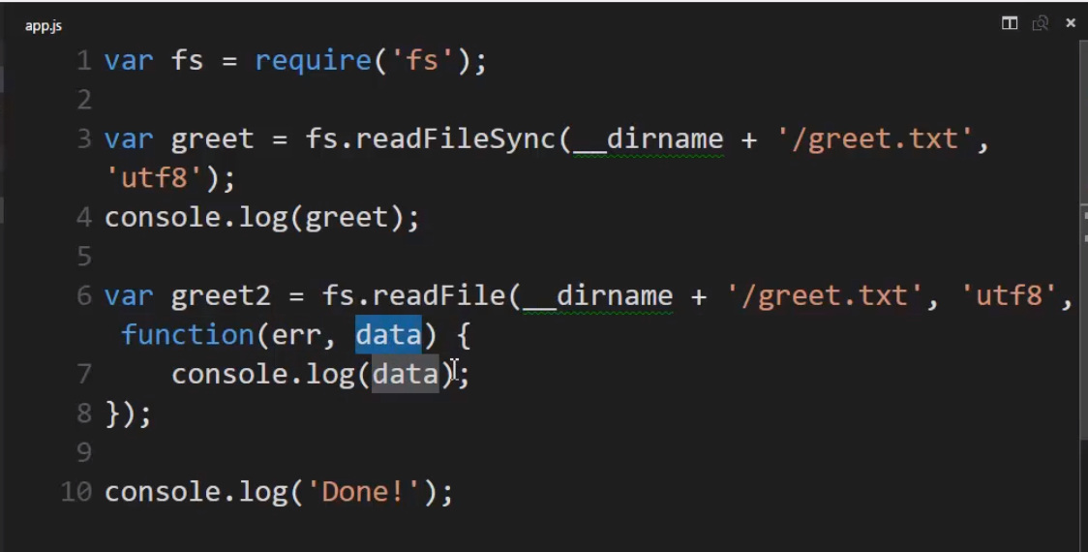

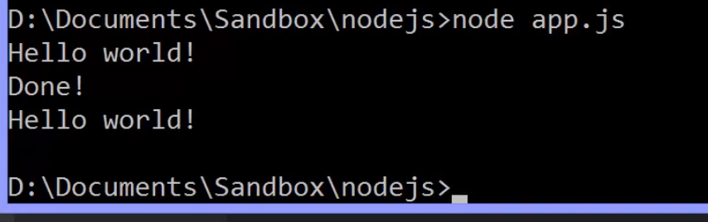

The done happened second.

Why?

Because this line of code ran, require function and got the fs object. This was specifically synchronous, so it waited until it got the contents of the file before moving on to the next line and then ran that console.log, so that was that first Hello world!

Then it ran this line of code.

**This says please go out and asynchronously get this file contents, and here's the callback for when you're done**;

and then V8 moved on and V8 was running its code while that file was being grabbed, so V8 ran that line of code.

And since the callback won't be executed until V8 is done running whatever code it was running, this last line will be run, so we see done;

and then, at that point, the event loop had said, oh, the file is done reading, so I can invoke the callback and so this function was invoked third.

**Now, we actually have one other problem here. The problem is that this is using a buffer to load the file contents, and a buffer is just data sitting in memory. It actually sits on what's called the heap in V8, meaning that it's just a spot where data sits, where data that the application is using; and so node sticks the buffer contents onto what's called the heap in V8, meaning the memory space that the JavaScript engine is using. If that file is very large and many people are running this programme, you'll end up with many buffers that are very large in size; and so all of a sudden you'll end up having problems in your application using a lot of memory.**

**This is a real problem. You could end up causing yourself a lot of grief when you actually put out your application in the real world. So we need a way, now that we've seen we can do it asynchronously for performance, to also minimise how much data we're working with at any one time inside the buffer.**

Let’s get that done in next chapter.

## Streams

a sequence of pieces of data, data that's broken up into what's called chunks.

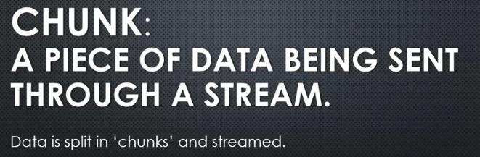

**So we take our data, we take our information, split it into chunks of some particular size and send them down the pipeline between whatever two points of communication are trying to send the data between.**

Take a look at streams inside the Node.js core on the JAVAscript side 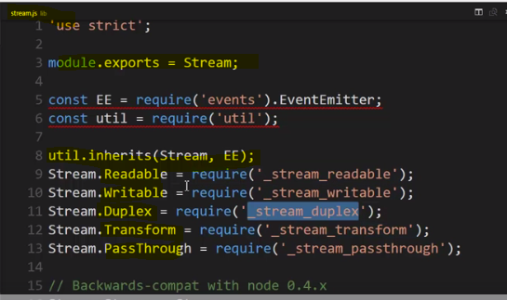

First of all, the thing that's exported from this module is the stream constructor. But notice something, stream inherits from EventEmitter. That is streams are event emitters.

So, any streams that are created have access to methods like on and emit. They have that idea of an object which contains an array of functions that can be invoked whenever we say that something has happened.

However, there is an old stream code, and there is the new stream code. There used to be just streams, but now there's a variety of types of streams, a Readable stream, defined in _stream_readable.js, and this various ones you could also take a look at.

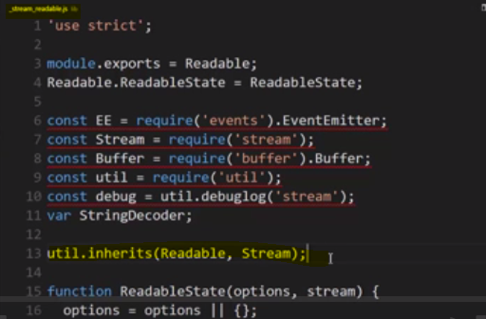

**Actually it inherits from stream. So that means that readable is a type of stream and also a type of event emitter, since stream is a type of event emitter.**

**A Readable stream, a Writable stream, a Duplex, a Transform, a PassThrough.**

**A readable stream means you can read the data, but you can only read the data that's coming through. You can't send any data back down the stream.**

**A writable is the opposite. You can send data to the stream, but you can't read any data from the stream.**

**A duplex lets you do both, read and write, and the transform lets you change the data as it moves through the stream. So it's written to the stream, and it's different when it's read.**

So that's just an example of some of these things, but the core idea is that you have types of streams,

There is one more piece of important information if you go and look up streams in the Node.js documentation. **Streams are merely a base or abstract class.**



when we create new objects of this type, we never directly go, give me a new stream.

We always build some kind of custom version of it, inherit from it, and then we make objects from that. Streams don't implement certain methods that are needed in order to actually use them. They implement the base of the idea of a stream,

and then it's up to us to decide how we're actually dealing with reading and writing information.

This turns out to actually be really powerful for us to build our own streams if we want, but there are plenty of streams out there available built for us of different kinds, including within the Node.js core itself.

Let's take a look at the prototype chain

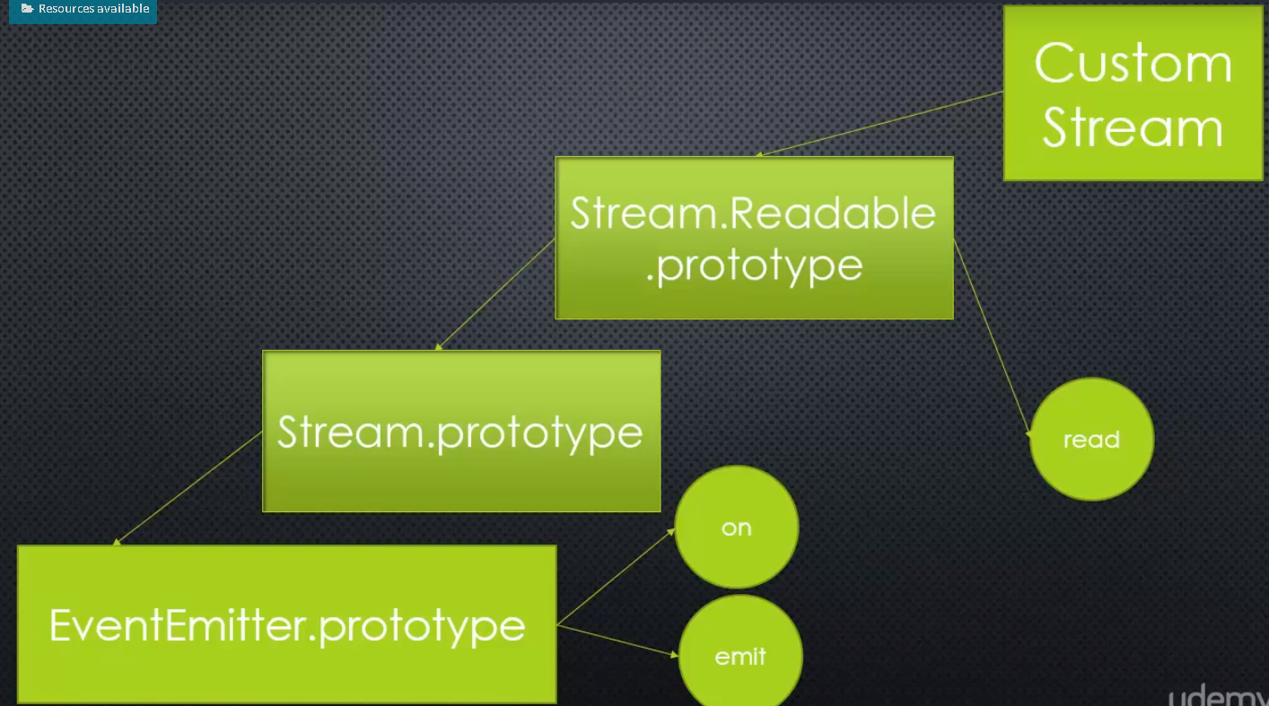

**since Streams are abstract, we never work with them directly. Instead, custom streams for particular purposes.**

The idea being that once we have our custom stream, whatever type of stream we're dealing with, it has available to it all of this functionality including the ability to emit and listen to events

**But when we say writable and readable, it's important to remember and realise that we're talking about writable and readable from Node's perspective, because these are streams of data. Somewhere on the other end, someone else is reading or writing as well.**

So, in our example of the client server model, like the web server running Node in the browser,

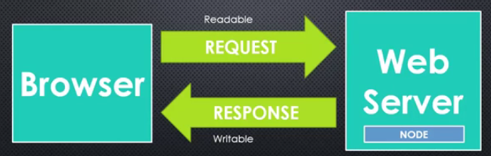

if the browser makes a request of the web server and Node responds then the request from Node's perspective is just readable, even though the browser wrote to it. It's the one sending the information. But from Node's perspective, it's only going to read the request from the browser. It's not going to write to that stream. And from Node's perspective, the response back from the browser or to the browser is writable, not readable. It's just sending information, but the browser is going to read it. So when we say readable or writable streams, it's not that they're truly, physically, only able to be written to or read, but from Node's perspective, this abstraction of this concept, it can only write or read to the stream.

Since streams are abstract, we never work directly with them, we need to look at a concrete implementation in order to actually try this.

The perfect spot to try this out is file system (fs.js). inside the fs module, the files module, there is a function called createReadStream.

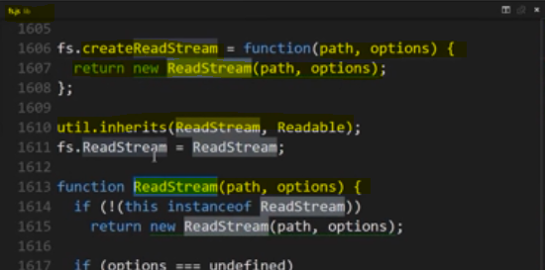

**ReadStream inherits from Readable. Readable inherits from Stream, and Stream inherits from EventEmitter.**

So, let's try using it.

For starters, I'll need a fairly big file, and what I did was did a search for lorem ipsum on Google. Lorem ipsum is just basically filler text, and so I found a generator. so I used lorem ipsum to generate a greet.txt file, and a fairly good-sized one.

I see that greet.txt is about 61 kilobytes in size.

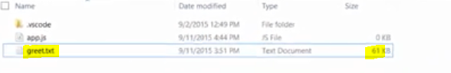

Now, a kilobyte is 1,024 bytes, and a byte is eight bits. So that's a lot of bits. But that gives me a file big enough that I can mess around with it a bit to understand streaming.

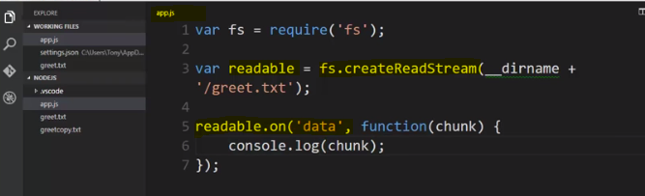

**Fs.createReadStream gives me ReadStream object. And because it has EventEmitter down the pipeline, I can listen to an event.**

And if you look in the documentation, **an event that's emitted by the ReadStream is data on data.** **what happens is the stream will fill a buffer. And so it will begin to read this file, and it will fill up the buffer with the contents.**

**Now, if the contents are the same size or smaller than the buffer, then you'll just get all the data, but if this text file is bigger than the buffer size, you'll get pieces of the text file at a time, where each piece is the size of the buffer.**

**So it will read some of the text file, fill the buffer, emit a data event, run all the listeners, then keep going, reading the rest of the file until it fills the buffer, then emit a data event, and that will invoke all of the listeners and keep going until it finishes the file.**

And **every time it emits the event and runs the listeners, it will actually pass the data that was in the buffer to the listener.** So I could go ahead and console.log this.

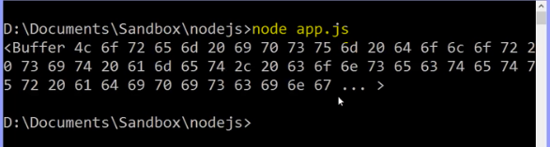

if I run this, I see that I'm getting the entire buffer, and I only got one, because, as it turns out, a file stream is a fairly large buffer size, by default, 64 kilobytes, but it was enough to get the entire data that I had in this text file.

first of all, get strings instead of buffers, I can specify options, which is an object. So I could say encoding, tell it the encoding. That will tell it, well, you can now take that binary data and figure out what letter each one should be.

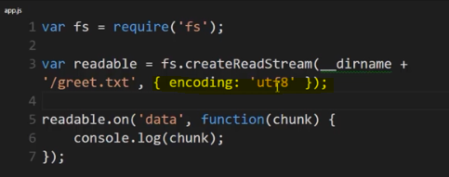

Output in String of contents of file - 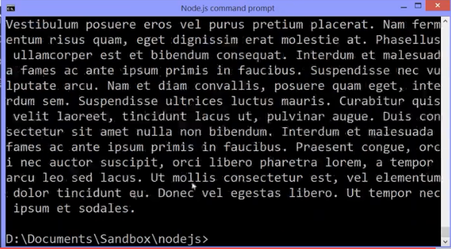

Lets look at string length of whole data of greet.txt – 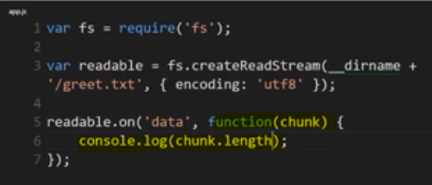

Output – 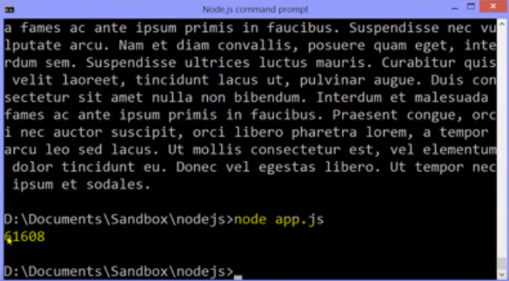

So it was slightly smaller than the buffer, it turns out, once it actually pulled all the data in off of the text file. The raw text itself was a bit less than 64 kilobytes.

So, how can we try to make this show what's really happening?

Well, **there's actually an option called highWaterMark, and this is actually the number of bytes that we want our buffer size to be**

**So I'll just say 32 times 1024, since this wants bytes. I want 32, and this is bytes, 1024 bytes per kilobyte. So this is 32 kilobytes.**

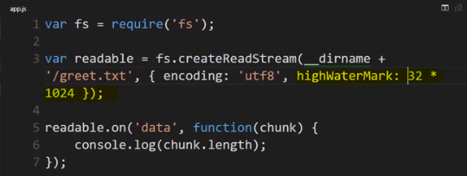

Output- 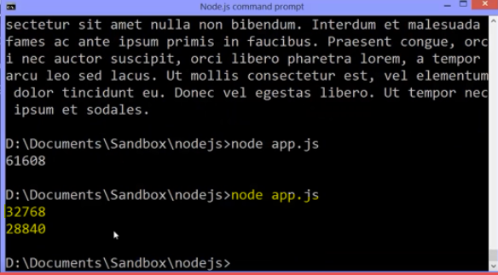

There, see the two chunks? 32 kilobytes, and then the rest.

And I could shrink down my buffer and say I want each chunk to be, at most, 16 kilobytes. There.

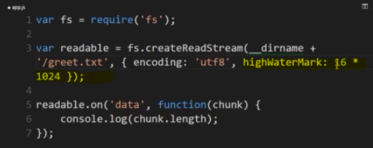

I got my event, my data event, four times.

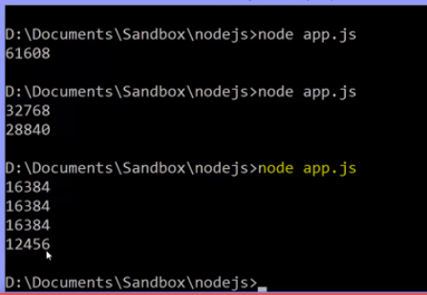

The stream emitted four chunks, and I could process them

**because this is a string, because I encoded it in UTF-8, so chunk itself is a string. I could console that actually string too in chuncks of whatever size we want and process each chuncks accordingly.**

**Now lets create a writable stream and copy(writing) the chunks that we received in new file.**

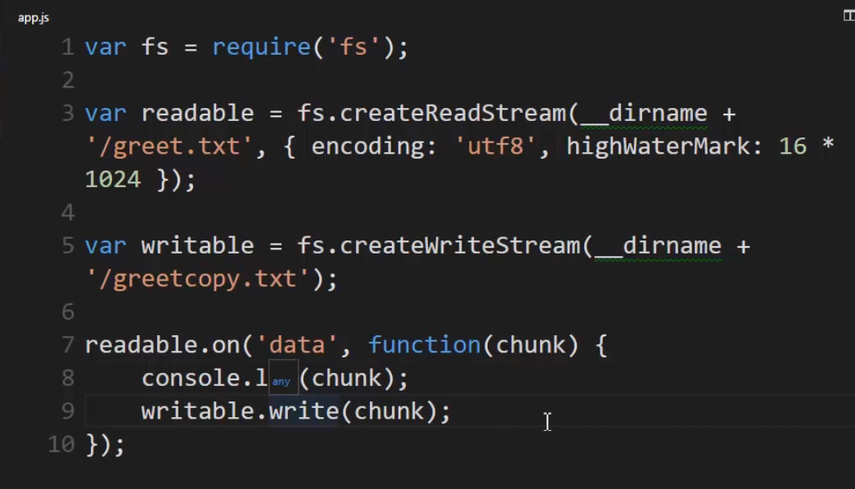

I can just say writable.write and send that chunk to the write stream, and since it's a file writing stream, when it receives that chunk, it will simply write it to the file.

so what should happen when I run this is it should take the contents of greet.txt and copy it to greetcopy.txt, one buffer size at a time.

**I just copied the files by listening for the data event, because a stream is an event emitter, and sending the data to the writable stream a piece at a time.**

**It also means I didn't need a massive buffer in order to work with the file. I didn't need to read the whole file in at once. I could send it in pieces and minimise the amount of memory that my programme, my application is using, on the server.**

Now, this is a very simple example, but it is the core of readable and writable streams. However, this little piece that we did here of listening for the stream to send data and then writing it to the other stream**, that's so common that there's actually an even faster and better way to do it within Node.**

## **Pipes**

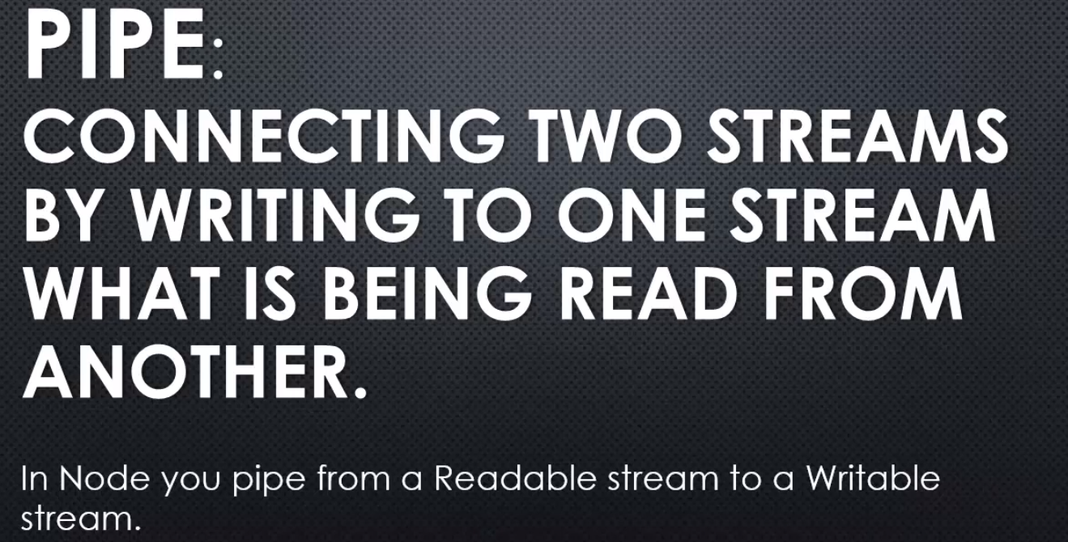

**So, you pipe from a readable, I'm reading what's coming in, each chunk and then I'm writing to the writeable stream that chunk,**

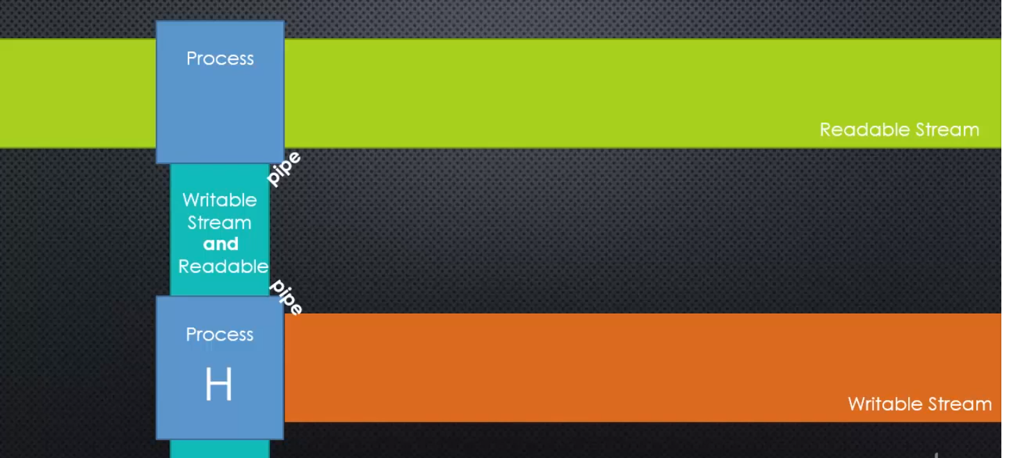

we can imagine a readable stream and we're reading a chunk from it, maybe one character, maybe many, whatever the buffer size is but the idea that we've read a chunk from a readable stream, and we send it to a writeable stream or pipe it to a writeable stream

**A pipe, so we read a chunk and we take that chunk and write it to the writeable stream, just like we did when we copied the files but the pipe then sends that chunk and if that writeable stream is also readable, then we could pipe it again to a different writeable stream, and just keep the chunks moving along, piping, piping, piping from stream to stream to stream, sending chunk to stream to stream to stream.**

**So, pipes can be chained or connected if you're sending them to different writeable streams. As long as you're starting with the stream that's readable and you move along to streams that are both writeable and readable, then you can pipe the chunk along a flow of streams, and do may different things with a chunk of data.**

## Pipes in Node

**idea of sending data from a readable stream to a writable stream as each chunk is processed is very common.**

**So** **Node.js implemented a method called pipe, that is available on a readable stream.**

let's go over to the Node.js source code and on the javascript side in the _stream_readable.js file, for example. I'll find a pipe method that's available to all readable streams.

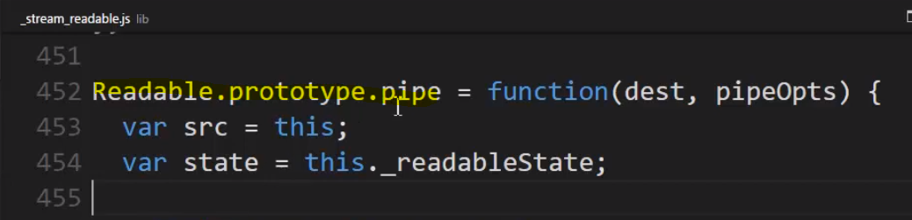

**pipe takes a destination. Where do we want to send this chunk to? This should be a writable stream.**

And there's plenty going on in here, but we'll just focus on one area that's most important for our purposes.

This is essentially the same thing that we did before. It looks for the data event on our readable and then runs a function, which is the listener, and writes that same chunk to the destination, so when we call the pipe function, we give it the destination as a parameter and then the pipe function will set up that same structure that we did.

Now it's a bit more robust but it's basically the same idea.

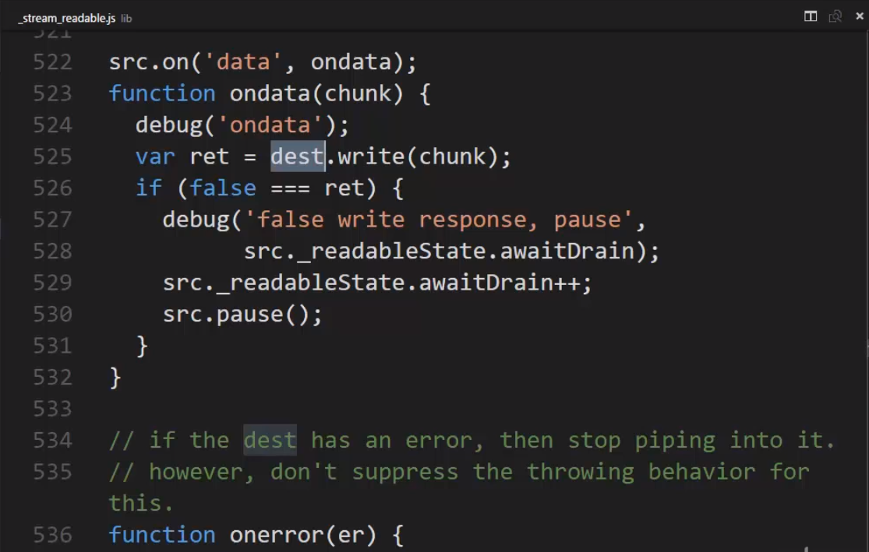

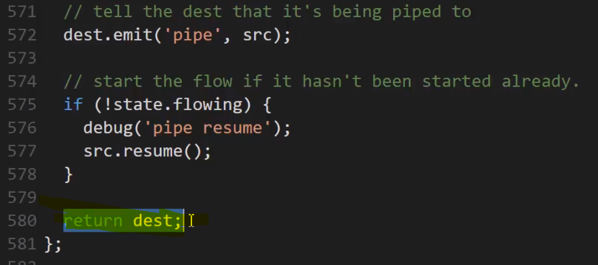And there's one more important thing that the pipe function does. If we scroll all the way down to the last line, we see that the pipe function returns a value.

The value it returns is the destination. So in other words, the value we gave the pipe function, the writable stream that we want to write to, the pipe function also gives that back to us after it's done doing the work it needs to do and that helps us write our code in a bit cleaner fashion.

Let’s implement this 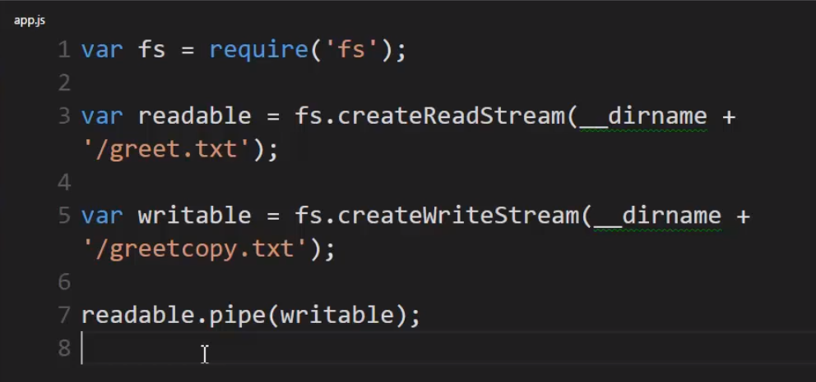

It worked . It sent the chunk from the readable to the writable using the event listener, just like I did before, but this is simpler and faster for me to code and to use and actually it gets even better.

**Remember the pipe function returns the destination, so if I give it this stream, that's what I'll have as the return value of the function. That means that if this was a readable stream, meaning some form of duplex, because I need to pipe to it so it has to be writable and now I'm looking to read from it, meaning it's readable. And if it's both readable and writable, then it's duplex, or transform. If it was, then it would be a readable stream and I could just call pipe on it, not pipe on readable, but pipe on the destination, because that's what's returned from this function.**

**So in that way, I can pipe the chunk through various streams as long as they're both readable and writable.** To do this then, we'll need a duplex or a transform stream to work with.

**files are a particular type of stream that we're working with, but that doesn't mean that we can only stream from a file to a file.**

**We can really stream a chunk of data to anything that is a stream, like an internet connection or in our case we're going to use something called zlib that is part of the Node core. This simply allows us to implement a gzip file.**

What's gzip?

Well, if you're used to the concept of a zip file, it's just a compressed file. Now gzip is a very common and particular algorithm for compressing files and Node has a built in component in order to compress and uncompress files.

Now if you're a Windows user, for example, and you see a gzip, you can't just right click on it and unzip it like a zip file. It's a different format, but, there are programmes in Mac, Linux, Windows. You can deal with gzips for free in any operating system.

So what we'll do is we'll copy the contents of greet just like we did before, but we'll also create a gzip, a compressed version of it.

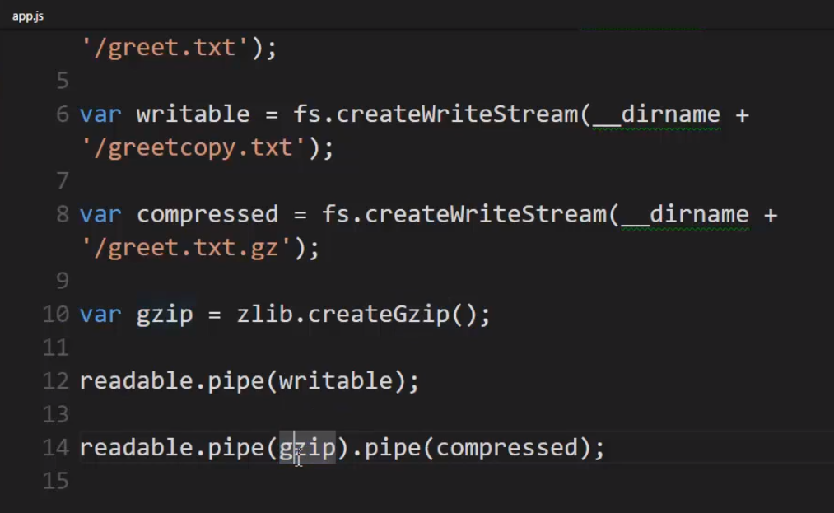

**gzip = zlib.createGzip.**

**It creates a transform stream. That means it's both readable and writable and every time a chunk is sent to it, it compresses that chunk, more or less. In other words, it's creating a compressed file, but it's a stream so it's dealing with the file a chunk at a time, which means since it's readable, not just writable, I can also pipe its output to another writable stream.**

So let's create another file stream. I'll call it compressed and we'll point it at greet.txt.gz. Now it's empty right now but I want to put the compressed version in that file

**Now I want to send it through the compressor. Notice that the zlib library is not doing anything with it. It's not saving it to a file. It's simply giving me an output. I give it a chunk of data and it gives me the proper output, the proper compressed output. So pipe will send my readable chunk to my writable stream and gzip will transform that chunk and since the pipe function returns the gzip stream, in this case, return is what I've given to it, I can just say.pipe because gzip is also readable so it also has a pipe method and I can pipe it to my writable compressed stream because I created a writable stream pointing at that file.**

So what's going to happen?

It will read from greet.txt and on every chunk pipe to gzip and gzip has a pipe which means on every chunk read from gzip will write to compressed so we're going from stream to stream to stream and this structure of method following method after each function call is called chaining.

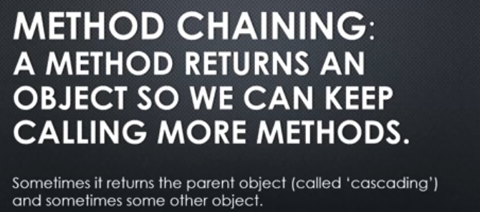

Alright, so again all we have is our file system library, our **zlib**.

**We're creating a readable stream to connect to greet.txt, a writable stream to greetcopy.txt, a compressed stream to greet.txt.gz and then we use the zlib to actually create the compressing stream, the one that actually transform changes to the data into a compressed version.**

So it run successfully – 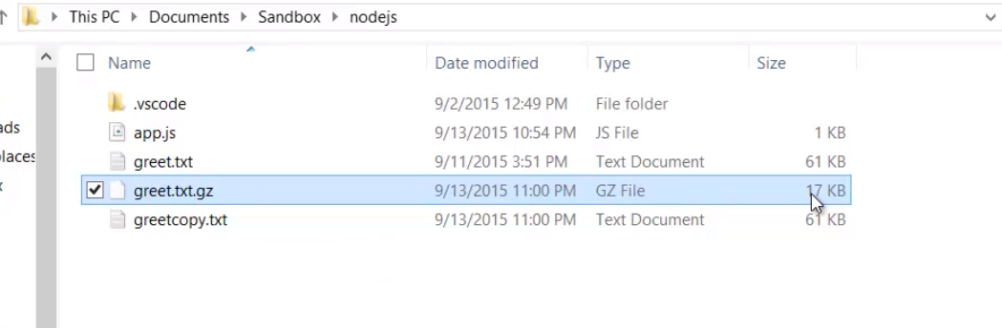

alright, so, it's important again to remember that we're only using files as an example.

**We could've also streamed this out if we had a stream that was doing an internet connexion or a stream sending data to a database. As long as the stream is implemented properly in that it handles a chunk of a data at a time, you can read and write and pipe data where ever you want from stream to stream, as long as they're properly readable, writable or both.**

This is very powerful and really the Node way of thinking about data. Node likes it when we work with streams because it helps Node be performant. It provides these methodologies for that purpose.

**so** **we should always be thinking about, "Where can I use a stream," because it minimises the buffer size that we're working with, therefore helping the amount of memory that our application is using and helping with the speed at which things seem to occur.**

**Your first instinct should be streams and asynchronous because it will help the performance of your application and you'll be taking full advantage of the power of these concepts within Node.js.**

## Web server checklist – (till here)

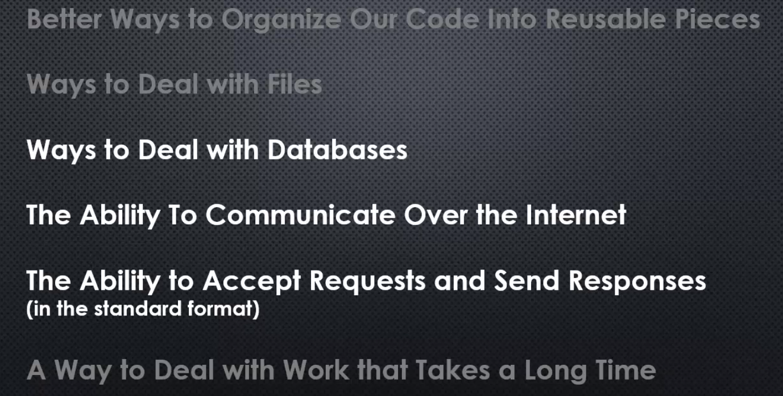

We've already seen that we can organise our code in better ways into reusable pieces using modules. NodeJS provided modules and now coming, are ES6 modules as part of JavaScript, as implemented by a JavaScript engine.

But now we've also seen that we have ways to deal with files. Node has provided both synchronous and asynchronous abilities

**We've also seen a way to deal with work that takes a long time. Just that very asynchronous concept is one of them. We can keep our code running in the V8 engine while other things are happening asynchronously within Node or in the operating system. And the event loop helps us then to know when that happens, and when V8 is done working, it will execute the callback that we ask it to.**

**we've also seen streams. Rather than dealing with large amounts of data at a time, we can deal with data a chunk at a time, so that even though it still takes time for those things to happen, we can deal with it in a way that's both more performant, better performing.**